# CS 255 System Design Document

## UML Diagrams

### UML Use Case Diagram

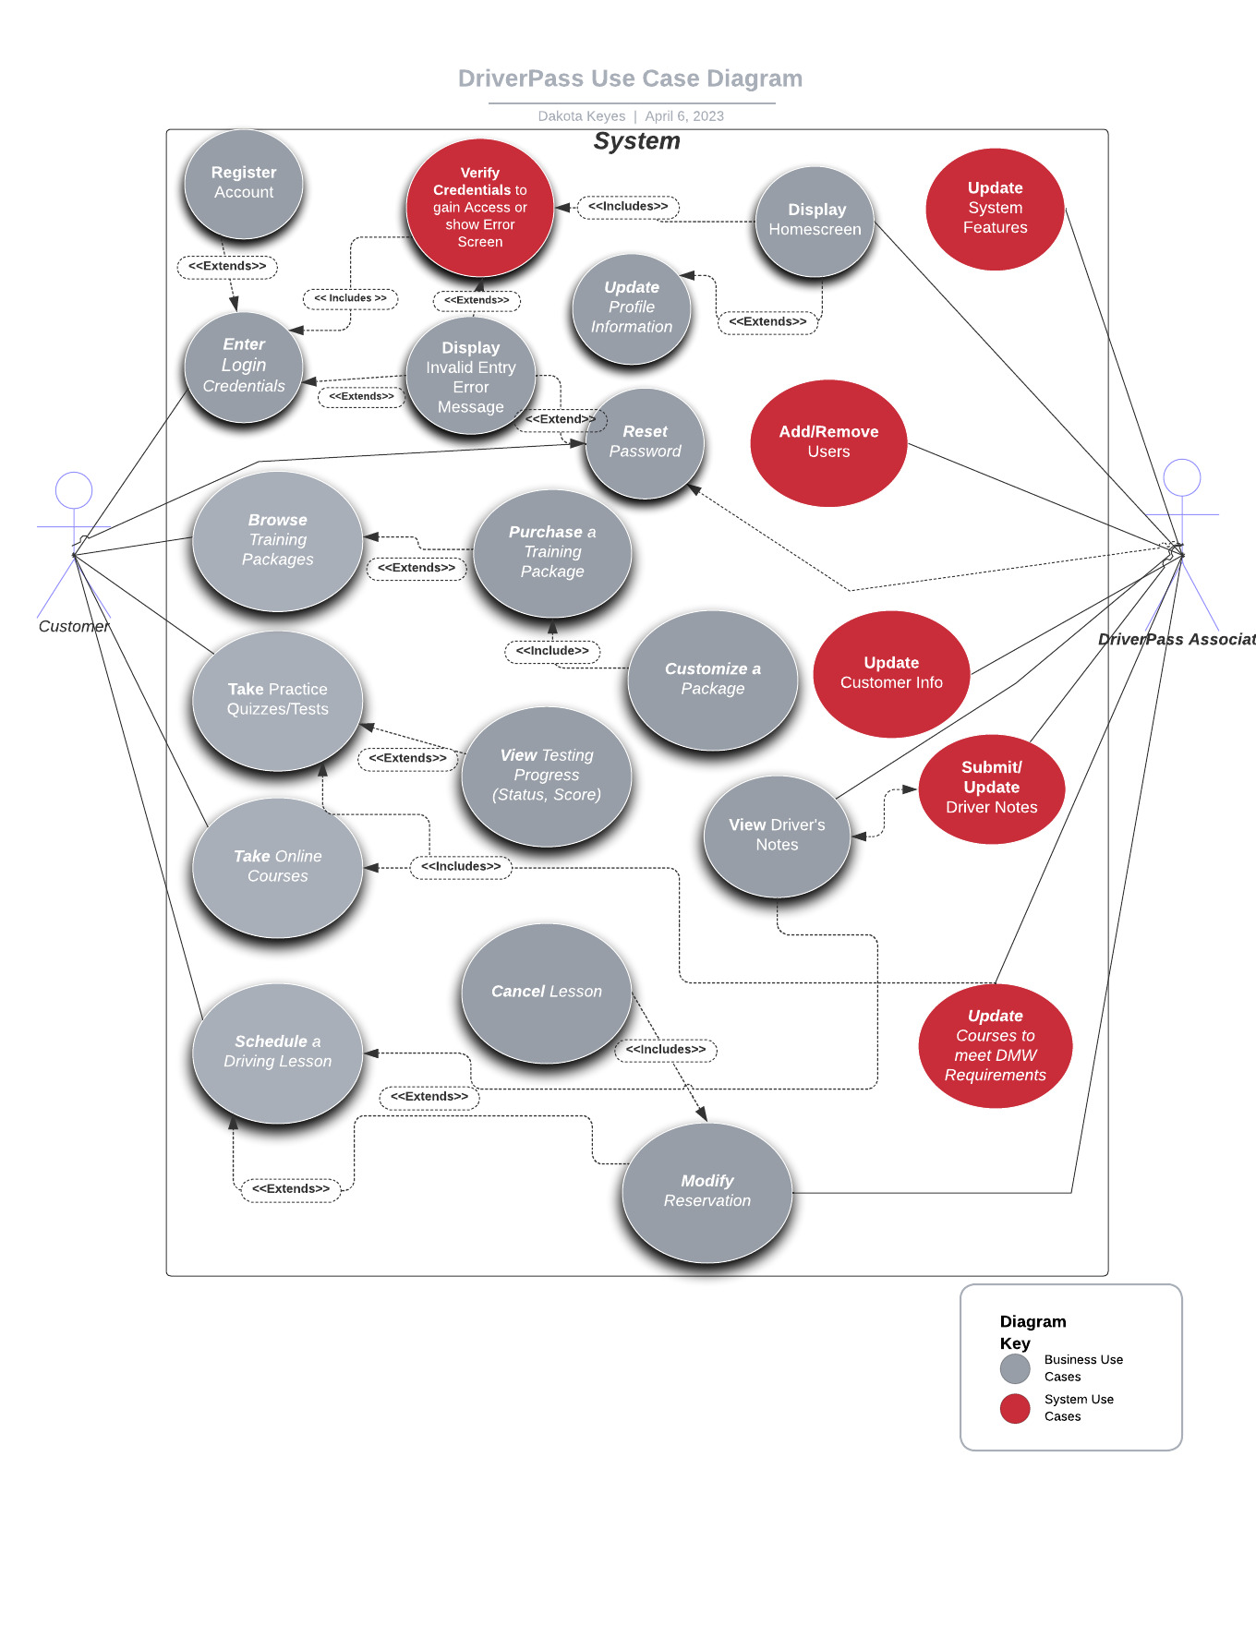

### UML Sequence Diagram



### UML Class Diagram

## Technical Requirements

*[Based on the diagrams you have created, describe the technical requirements of your system. These requirements should address the required hardware, software, tools, and infrastructure necessary for your system design.]*

**Hardware:** Based on the recommendations, Linux cloud server would be the best option. This would illuminate the need for a physical on-site server and some security and maintenance that is necessary for a server-based system. Other hardware would be user devices that would allow access to a web browser. Smartphones (both Apple and Android), tablets, desktops, laptops, etc.

**Software:** Using the Linux operating system, a web-based distributed system will be necessary. Multiple browser options will need to run and access the system. Google Chrome, Safari, and Firefox will all need to support web-browsing and access. Using the clients OS (Mac, Linux, or Windows) they will be able to access the system. This is referred to as platform-agnostic.

**Tools:** IDE for developing the system, such as Eclipse or Visual Studios, would be good options. Jenkins or another continuous integration tool as well as an automated testing server would help the development process run more quickly and efficiently. Other necessary components are the computers, laptops, etc. to develop the system.

**IT Infrastructure:** Scaling out an infrastructure to a larger system might be necessary in the future. An infrastructure will help improve performance and speed which are both vital to a successful system. High-speed internet and 5G capabilities will also improve system performance.